1. ***INSTALL DOCKER***

Install docker desktop for mac(we can’t use command line version as that is only available for linux)

Docker Desktop is a one-click-install application for your Mac, Linux, or Windows environment that lets you build, share, and run containerized applications and microservices.

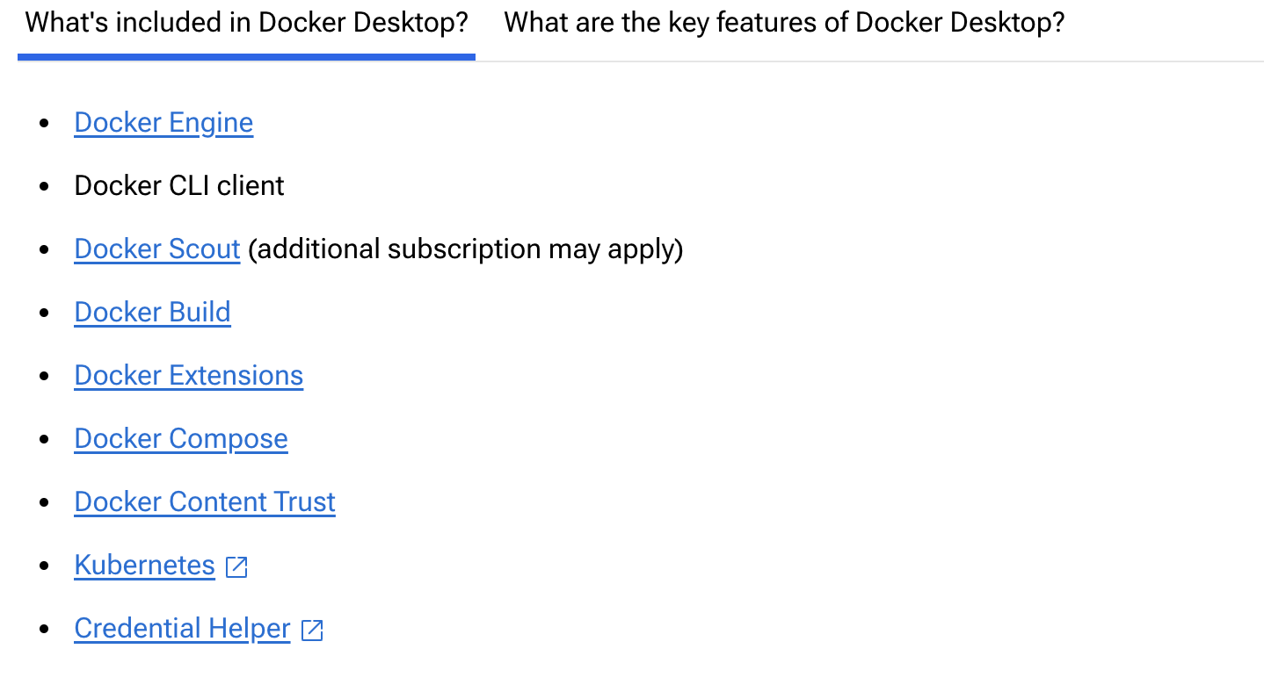

2 ways of installing docker desktop on mac-either mac with intel chip or mac with apple silicon chip

<https://docs.docker.com/desktop/setup/install/mac-install/>

1. ***INSTALL GIT***

<https://git-scm.com/downloads/mac>

first install homebrew

Homebrew installs [**the stuff you need**](https://formulae.brew.sh/formula/) that Apple (or your Linux system) didn’t.

Homebrew installs packages to their own directory and then symlinks their files into /opt/homebrew (on Apple Silicon).

1. WHEN INSTALLING HOMEBREW, I GOT INTO A PROBLEM THAT IT WAS NOT UPDATING HOMEBREW, SO HAD TO RUN THE FOLLWING COMMAND TO CHANGE THE PERMISSIONS FOR THE USER-VARDAAN KAPOOR AND THEN HAD TO RUN THE INSTALL COMMAND AGAIN

sudo chown -R vardaankapoor /usr/local/var/homebrew

1. Now install git using homebrew
2. Set up git and add ssh key to login to github account

<https://docs.github.com/en/authentication/connecting-to-github-with-ssh/about-ssh>

for configuration we have to run 2 commands

git config --global user.name "Bucky Badger"

* git config --global user.email uw-bucky-badger@wisc.edu

1. Get ssh keys for the laptop
   1. First we create ssh keys and attach them to a paraphrase

<https://docs.github.com/en/authentication/connecting-to-github-with-ssh/generating-a-new-ssh-key-and-adding-it-to-the-ssh-agent>

before making new keys for this laptop, make sure that no existing keys already are present

<https://docs.github.com/en/authentication/connecting-to-github-with-ssh/checking-for-existing-ssh-keys>

type the command to list all the files in the ssh keys directory-if the command doesn’t run then there are no existing keys associated with this laptop

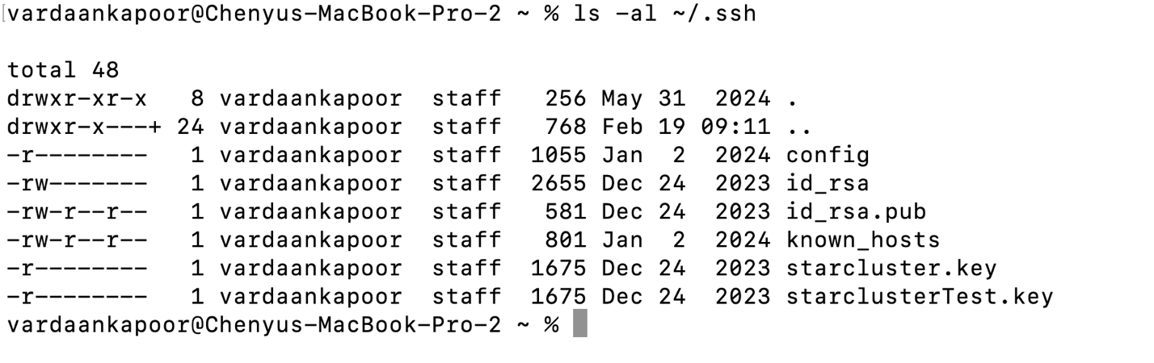

This shows that there are keys associated with this laptop-so we can use them only

* 1. ALTERNATIVELY WE CAN CREATE A NEW KEY PAIR

<https://docs.github.com/en/authentication/connecting-to-github-with-ssh/generating-a-new-ssh-key-and-adding-it-to-the-ssh-agent>

* + 1. Step 1 is to generate new key pair
    2. Step 2 is to add it to ssh agent
  1. NOW ADD THE ACTUAL KEYS(PUBLIC+PRIVATE PAIR) TO THE SSH AGENT/OR THE GITHUB ACCOUNT

<https://docs.github.com/en/authentication/connecting-to-github-with-ssh/adding-a-new-ssh-key-to-your-github-account>

* 1. ***CLONE GITHUB CLASSROOM’S REPOSITORY WHICH IS CREATED FOR JUST ME***
     1. First clone the repository using https method

We have to give our personal access token instead of password when we are prompted for it

To find personal access token go to this site and either find your personal access token or make a new one

<https://docs.github.com/en/authentication/keeping-your-account-and-data-secure/managing-your-personal-access-tokens>

when this token is created, please save it in a text file as we can’t see it ever again

then use it again as the password when cloning the repository

* 1. ***Connect docker file to vs code and share github credentials with docker***

Connect docker file to vscode

<https://gist.github.com/yohhaan/b492e165b77a84d9f8299038d21ae2c9>

* + 1. We first use command+shift+p to open vscode’s command palette
    2. Then in the command palette we enter “dev-containers:open folder in container” and press enter
    3. Then we are taken to choose the folder which will be contained in the container which the vs code now will build for us
    4. When we choose the folder, then automatically everything happens and github copilot asks to login via github and we will say yes
    5. Now at end we will see that the whole folder is now contained in a container and automatically a folder called “ .devcontainer” is made in the container which was previously not there
    6. This .devcontainer cannot be made by us as it can only be built by an operating system-thus it is automatically made when we make a container from a folder/directory
    7. This .devcontainer folder contains the 2 files called dockerfile and devcontainer.json file

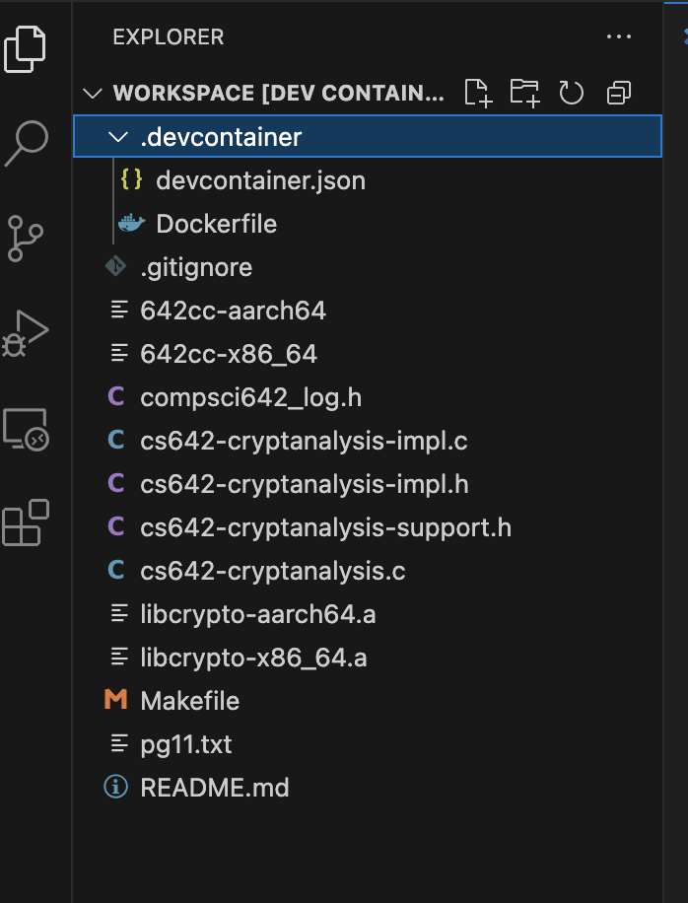

* + 1. SHARE GITHUB CREDENTIALS WITH DOCKER (IF NECESSARY, THEN ONLY)

<https://code.visualstudio.com/remote/advancedcontainers/sharing-git-credentials>

* 1. ***EXPLICITLY CONNECTING DOCKER TO PROJECT-NOT NEEDED IF WE CAN DO STEP 5 SUCCESSFULLY USING VSCODE***

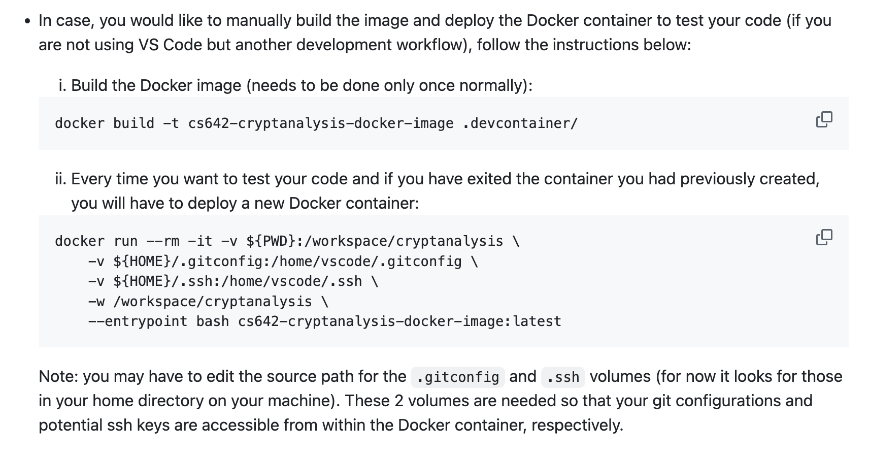

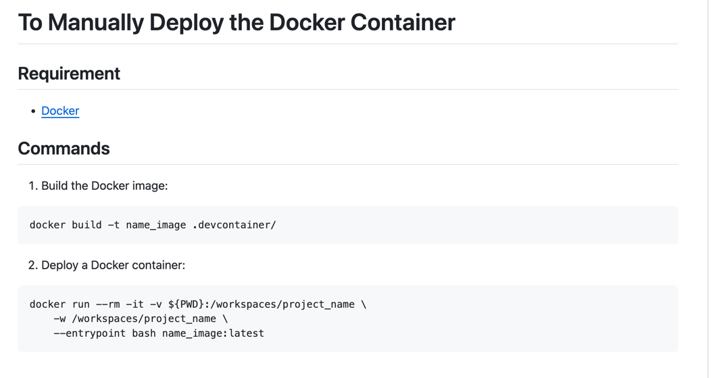

* 1. ***USING GNU/VM IF STEPS 1-6 OF USING DOCKER DON’T WORK***

